Formation and restacking of disordered smectite osmotic hydrates
Supplementary Information

Benjamin Gilbert^{1,+}, Luis R. Comolli^{2,+}, Ruth M. Tinnacher¹, Martin Kunz³, and Jillian F. Banfield^{4,}*
¹ Earth Sciences Division, Lawrence Berkeley National Laboratory, Berkeley, USA
² Life Sciences Division, Lawrence Berkeley National Laboratory, Berkeley, USA
³ Advanced Light Source, Lawrence Berkeley National Laboratory, Berkeley, USA
⁴ Earth and Planetary Sciences, University of California – Berkeley, Berkeley, USA
*E-mail address of corresponding author: jbanfield@berkeley.edu
⁺Equal co-authors

1. Clay Pretreatment and Characterization
A commercially available, well characterized Source Clay (Na-montmorillonite, SWy-2, from the Source Clays Repository of The Clay Minerals Society) was selected to facilitate a subsequent comparison with other data from the literature. The material is known to contain considerable amounts of impurities such as quartz (8%), feldspars (16%), and calcite (Costanzo and Guggenheim, 2001; Chipera and Bish, 2001; Mermut and Cano, 2001). Hence, prior to its use, the clay was pretreated to remove major mineral impurities, and to minimize a potential calcium release due to Ca-carbonate dissolution during experiments. Treatment methods were selected to effectively remove mineral impurities while preserving the original clay characteristics as much as possible.
Pretreatment steps included: (1) the removal of calcite impurities using a sodium acetate/acetic acid solution; (2) the equilibration of the clay with a sodium chloride solution, the background electrolyte used in later experiments; (3) the removal of excess Na-salts with Nanopure water; (4) the separation of quartz and feldspar impurities from clay particles by centrifugation; and (5) oven-drying of the purified clay-mineral phase.
At the beginning of the pretreatment, dialysis membranes (SpectraPor #7, 8kDa MWCO, 40 mm flat width) were cleaned by soaking in (30 min) and thorough rinsing with Nanopure water three times each. Then, ~30 g of the original source clay (used as received) was weighed into a glass beaker and 60 mL of extractant solution (1 M sodium-acetate/glacial acetic acid (0.5635 M), buffered at pH = 5) was added. After stirring the suspension with a disposable transfer pipette for ~1 min, the suspension was poured into a 26 cm long, pre-cleaned dialysis bag using a glass funnel. This step was repeated ten times to generate a large batch of purified clay minerals. Then, clay contained in two dialysis bags was dialyzed against ~4 L of extractant solutions in large glass beakers over a period of ~20 h. Afterwards, the pH and conductivity of each buffer solution was recorded for comparison with their values prior to dialysis. Dialysis bags were then brought into contact with fresh sodium acetate/glacial acetic acid buffer solutions of the same volume, and the dialysis was continued over another 5–6.5 h. This extraction procedure was continued for a total of six dialysis steps over various, individual dialysis timeframes (20, 5–6.5, 17, 24, 5, and 46 h) [Authors: Why are these times not given in sequential order? What is the reason for timeframes being of different length for each step? Same comment for series below.] while recording pH and conductivity values of buffer solutions repeatedly. Then, the buffer-solution composition was changed to a 1 M NaCl solution, again following a similar buffer exchange and monitoring procedure with a total of five steps with individual dialysis times of 14.5, 7.5, 17, 9.5, and 12 h. Finally, excess salts were removed from the clay by dialysis against Nanopure water over a series of five buffer exchanges with dialysis times of 5.5, 4, 17, 6.5, and 22.5 h.
Afterwards, the clay was removed from the dialysis bags and resuspended in Nanopure water completely by stirring of the suspensions in glass beakers, sonication, and shaking by hand in Corning glass bottles. Then, 950 mL batches of clay suspension were poured into centrifugation liners and centrifuged on a Beckman Avanti J-25 centrifuge at 1200×g over a period of 10 min. Based on Stokes law, this centrifugation time allows for removal of particles of an average size of >2 µm from suspension, which is believed to be an appropriate size cut-off for quartz and feldspar impurities. After retaining the fine clay fraction in the supernatant solutions, the centrifugation step was repeated once or twice based on visual evaluations of color differences between the light-colored clay fraction and the dark-colored, coarse mineral impurities.
After centrifugation, the supernatant solutions were dried in a VWR convection oven set at 45°C (actual oven temperature: 42–43°C) until apparent dryness was reached. The dried mineral was milled in 10 mL capsules using a Retsch MM 400 ball mill at a frequency of 30/s over a 2 min period in a series of batches.
(level 1) References

Chipera, S.J. and Bish, D.L. (20010 Baseline studies of the Clay Minerals Society Source Clays: Powder X-ray diffraction analysis. Clays and Clay Minerals, 49, 398–409.
Costanzo, P.A. and Guggenheim, S. (2001) Baseline studies of the Clay Minerals Society Source Clays: Preface. Clays and Clay Minerals, 49, 371–371.
Mermut, A.R. and Cano, A.F. (2001) Baseline studies of the Clay Minerals Society Source Clays: Chemical analysis of major elements. Clays and Clay Minerals, 49, 381–386.

Composition (wt.%) | SWy-2, untreated | SWy-2, treated
SiO₂ | 64.8 ± 2.1 | 62.7 ± 0.84
Al₂O₃ | 20.6 ± 1.4 | 23.81 ± 0.27
FeO | 3.38 ± 0.38 | 3.88 ± 0.43
MgO | 2.73 ± 0.15 | 2.52 ± 0.08
CaO | 0.58 ± 0.08 | 0.03 ± 0.02
Na₂O | 1.68 ± 0.33 | 3.38 ± 0.02
K₂O | 0.23 ± 0.11 | 0.05 ± 0.02
TiO₂ | 0.11 ± 0.05 | 0.11 ± 0.03

Table S1. Composition analysis of untreated and treated SWy-2 smectite.

Electron Microprobe Analysis (EMPA). Dried clay was pressed into powder pellets, carbon coated, and analyzed by electron microprobe analysis (EMPA) using a Cameca SX-51 in the Department of Earth and Planetary Science at the University of California, Berkeley. Data acquisition, analysis, and correction procedures were conducted using the software Probe for EMPA. Analyses were conducted with a 15 keV accelerating voltage, a 10 nA beam current, and a 20 μm beam diameter. Elements were acquired using analyzing crystals as follows: LiF for FeKα, MnKα, and CrKα; PET for CaKα, KKα, TiKα, and ClKα; and TAP for NaKα, SiKα, AlKα, MgKα, and FKα. The counting time was 10 s on peak and background for all elements. The intensity data for AlKα, NaKα, and KKα were corrected for time-dependent intensity (TDI) loss (or gain) using a self-calibrated correction. Average elemental detection limits at the 99% confidence interval were 0.052 for Si, 0.025 for Al, 0.037 for Ti, 0.208 for Fe, 0.184 for Mn, 0.025 for Mg, 0.031 for Ca, 0.196 for Na, 0.032 for K, 0.176 for Cr, 0.359 for F, and 0.032 for Cl. All Fe is reported as Fe₂O₃.
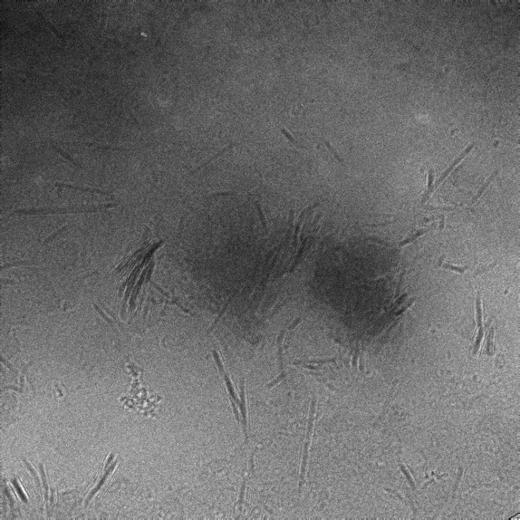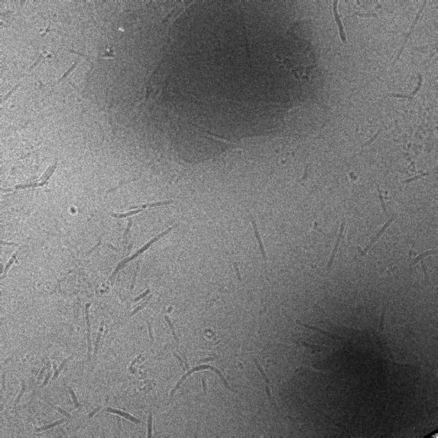
A
B

Figure S1. Defocused diffraction large field of view images of treated clay SWy-2 at 20 µg/mL in 0.1 M NaCl. Images are approximately 1 µm on each side.
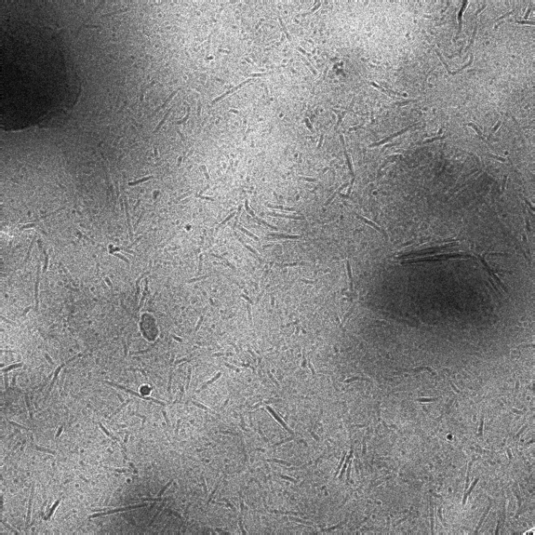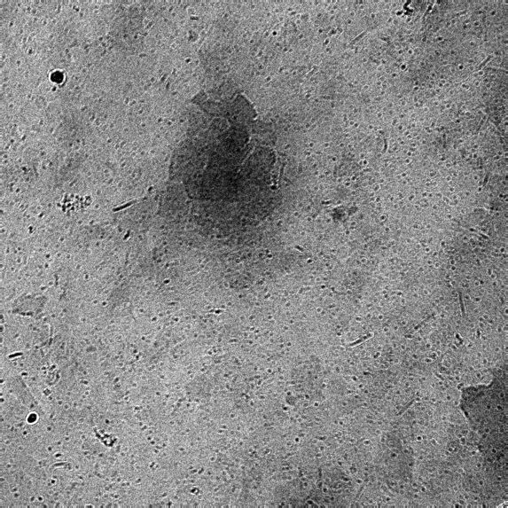
A
B

Figure S2. Defocused diffraction large field of view images of treated clay SWy-2 at 20 µg/mL in 0.1 M NaCl. Images are approximately 1 µm on each side.
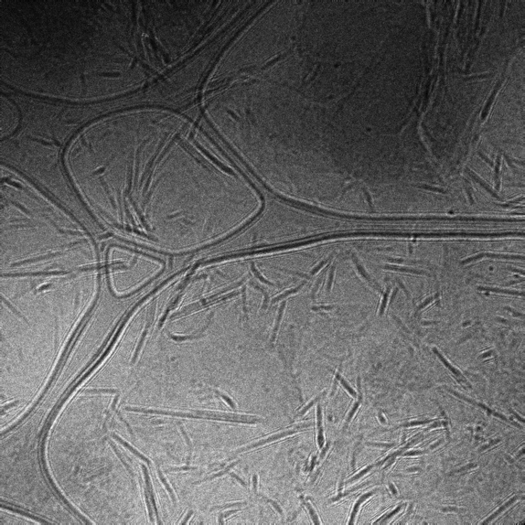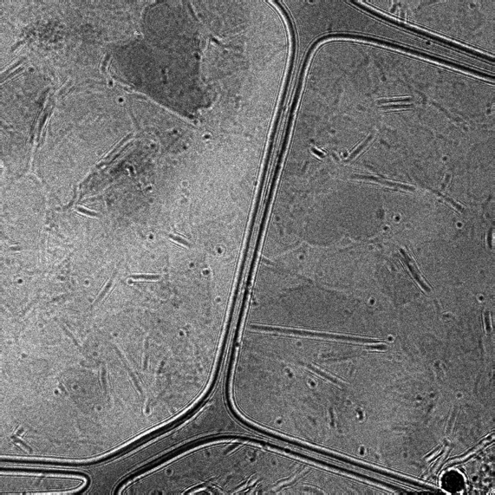
A
B

Figure S3. Defocused diffraction large field of view images of treated clay SWy-2 at 20 µg/mL in 0.1 M NaCl. Images are approximately 1 µm on each side.

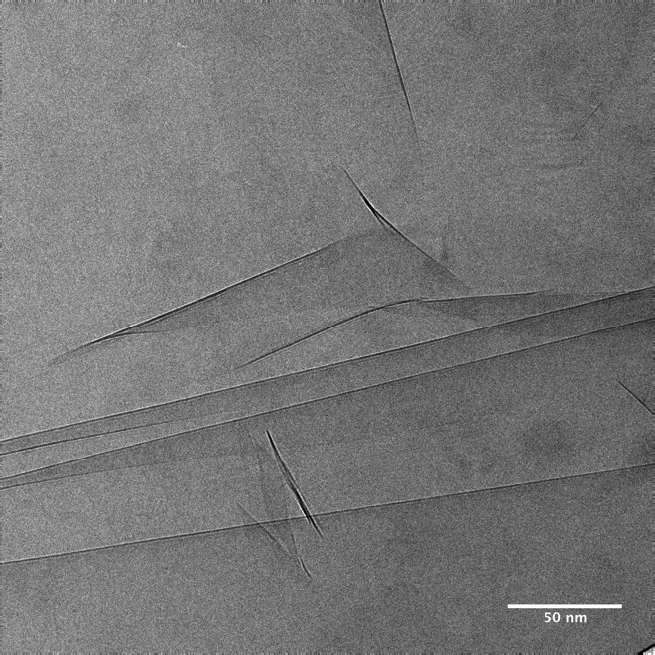

Figure S4. Cryo-TEM image of untreated Wyoming smectite SWy-2 equilibrated in 0.1M NaCl at 20 µg/mL showing almost completely exfoliated clay layers. The image is 286 nm long on each side.

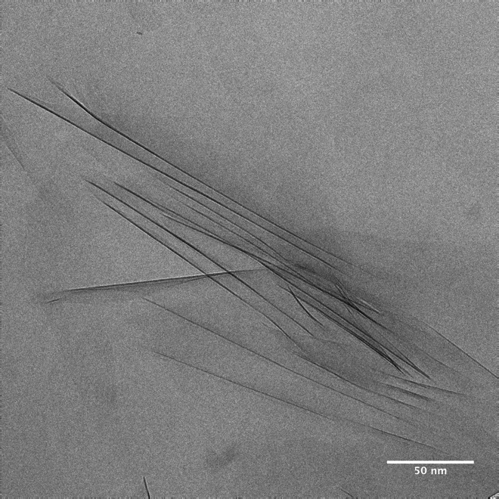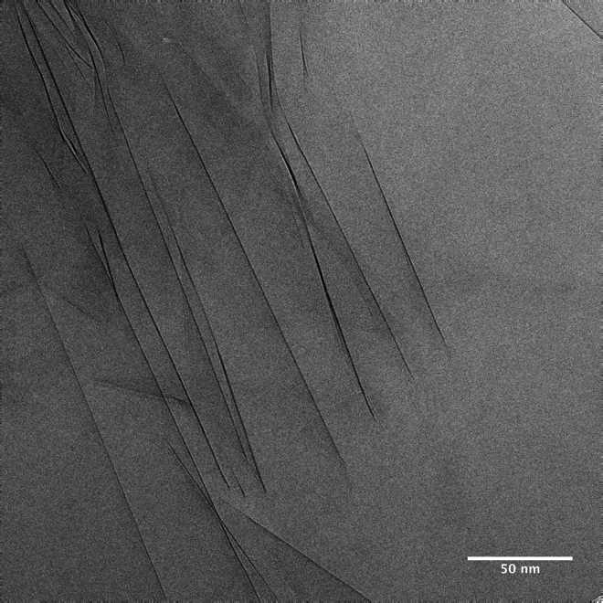
B
A

Figure S5. Cryo-TEM images of untreated Wyoming smectite SWy-2 equilibrated in 0.1 M NaCl at 20 µg/mL. A. An example of less ordered stacking configurations in the osmotic hydrate state. B. Evidence of parallelism in stacking arrangements despite the interlayer separation being considerably greater than the expected equilibrium distance for the osmotic hydrate.

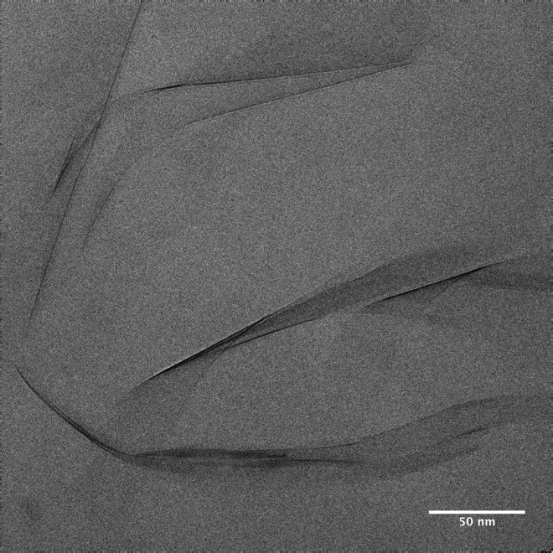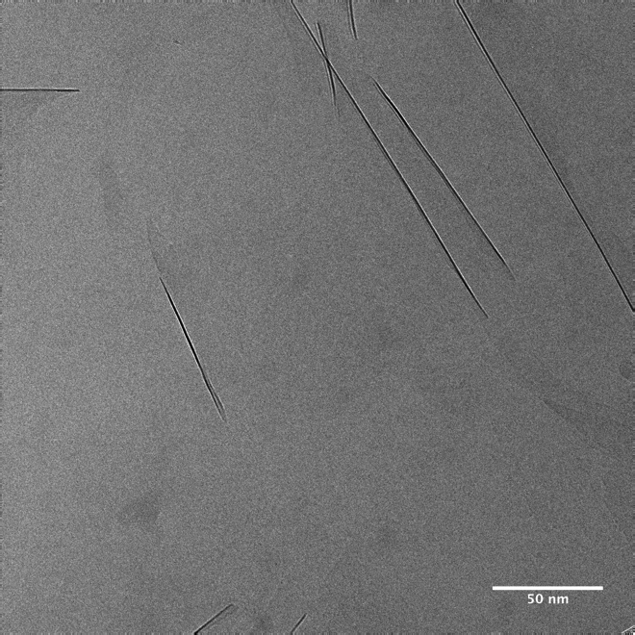
A
B

Figure S6. Cryo-TEM images of treated Na-montmorillonite from SWy-2 equilibrated in 0.1 M NaCl at 20 µg/mL. The images shows completely delaminated individual clay layers with (A) curled and (B) straight morphologies.

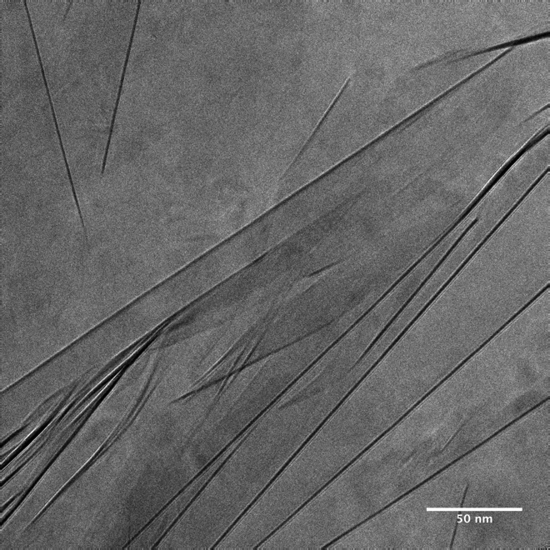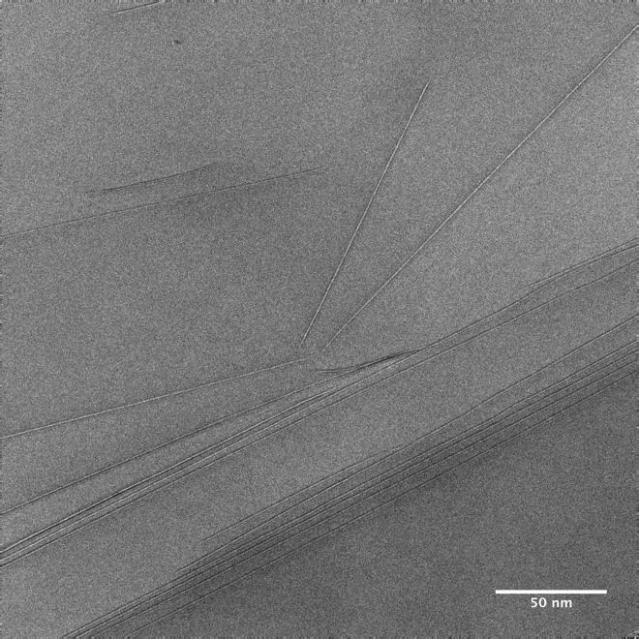
B
A
Figure S7. Cryo-TEM image of treated Na-montmorillonite from SWy-2 equilibrated in 0.1 M NaCl at 20 µg/mL. A An example of a disordered stacking configuration with the interlayer distances exceeding those expected for the osmotic hydrate state. B An example of coexisting parallel and non-parallel layers.
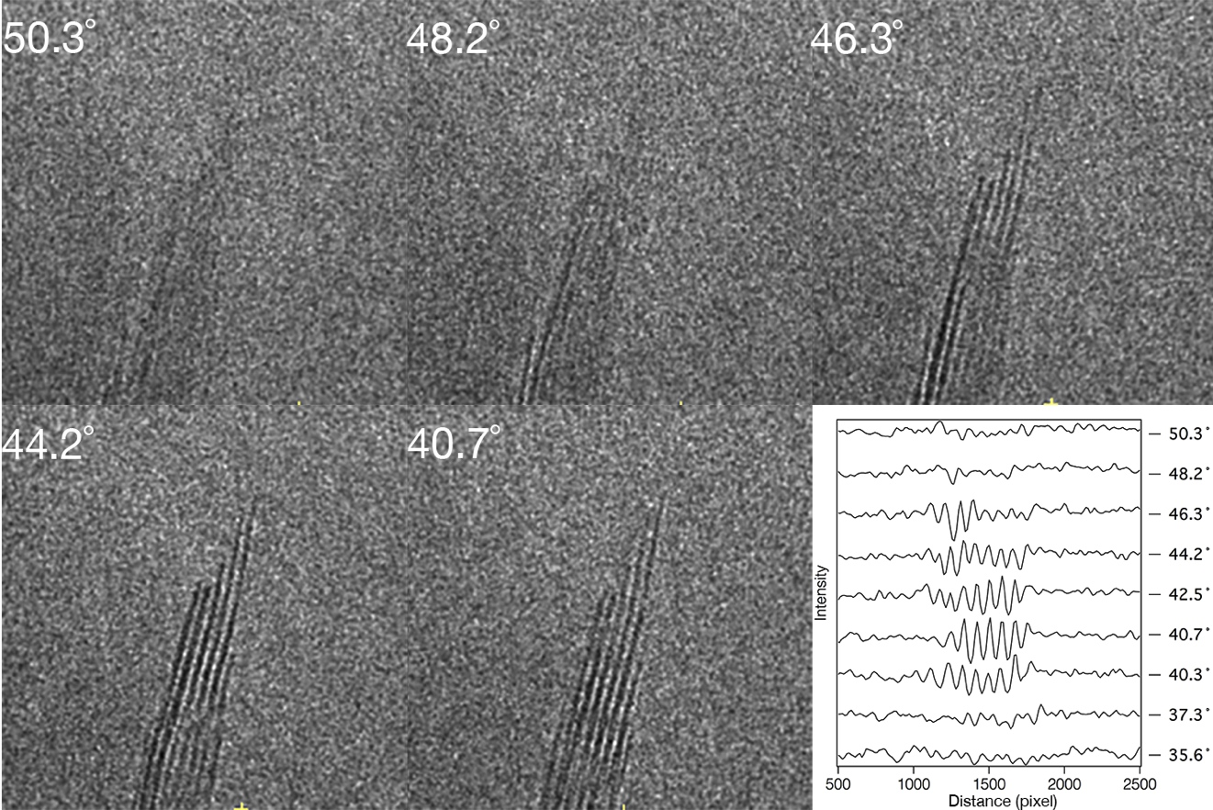

Figure S8. Tilt series showing the change in contrast as a function of angle. The plot of intensity profiles (acquired for a larger range of angles) shows that lattice contrast is lost over ~10˚ (i.e. ± 5°).

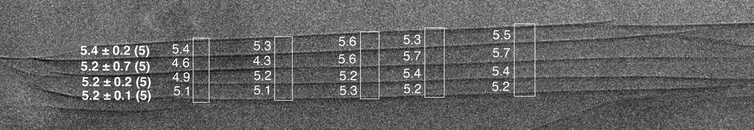

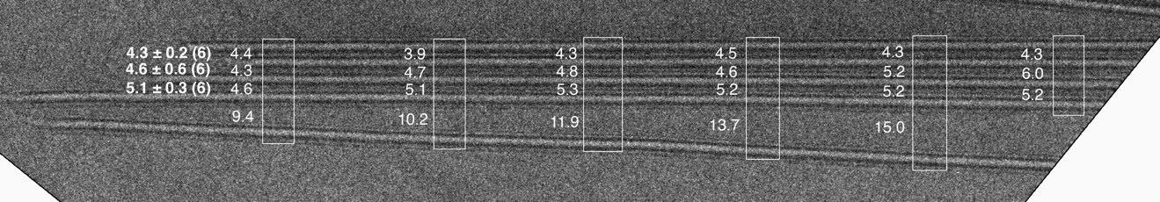

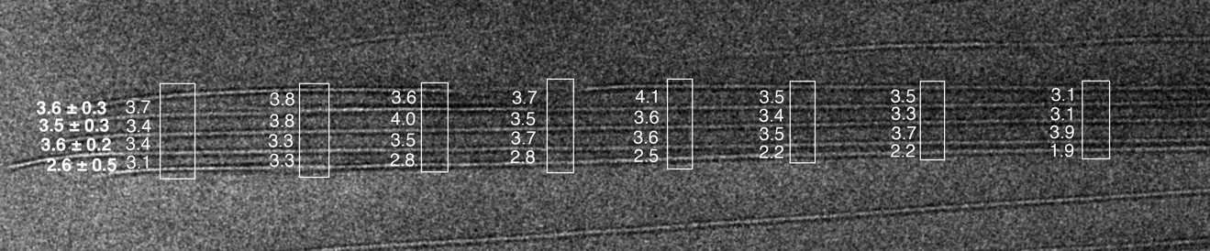

Figure S9. Studies of layer parallelism in the smectite osmotic hydrate particles shown in Figures 1 and 3. The boxes indicate the locations where interlayer spacing was measured, with the results reported on the left of each box in nanometers. The averages and standard deviations are give in bold on the left, and reported in the main figures.

