Molecular dynamics simulations of anion exclusion in clay interlayer nanopores: supplementary information
Donnan equilibrium (DE) model. By the second assumption of the DE model, the chemical potential μ_{i} of an ion i in either phase may be expressed as
(Low, 1951):
$μ_{i}=μ_{i,0}+R∙T∙ln\left(γ_{i}∙m_{i}\right)=μ_{i,0}+R∙T∙lna_{i}$, | (A-1)

where μ_{i,0} is the chemical potential of ion i in the Standard State, assumed to be the same for ions in either phase, R is the molar gas constant (8.314 J·mol⁻¹·K⁻¹), T is absolute temperature (K), m_{i} the molality of i (mol·kg⁻¹), γ_{i} the activity coefficient, and a_{i} the activity. By the first assumption of the DE model, chemical equilibrium exists between the two phases and, therefore, the partial molal Gibbs energy (${\overline{G}}_{i}$) of an ion in the bulk aqueous solution (superscript soln) and the hydrated clay phase (superscript clay) are equal:
${\overline{G}}_{i}^{soln}={\overline{G}}_{i}^{clay}$. | (A-2)

By an assumption that goes beyond thermodynamics
(Babcock, 1960), the partial molal Gibbs energy can be expressed as the sum of a purely chemical term and a purely electrostatic term, both in the bulk aqueous solution and in the hydrated clay phase:
${\overline{G}}_{i}^{}=μ_{i}+z_{i}∙e∙N_{A}∙ψ$, | (A-3)

where z_{i} is the valence of ion i, e is the proton charge (1.602·10⁻¹⁹ C), N_{A} is the Avogadro constant (6.022·10²³ mol⁻¹), and ψ is the (uniform) electrostatic potential in the phase of interest. The combination of Equations (A-2) and (A-3) yields:
$μ_{i}^{soln}+z_{i}∙e∙N_{A}∙ψ^{soln}=μ_{i}^{clay}+z_{i}∙e∙N_{A}∙ψ^{clay}$. | (A-4)

The introduction of Equation (A-1) then gives:
$$μ_{i,0}^{soln}+R∙T∙\ln\left(γ_{i}^{soln}∙m_{i}^{soln}\right)+z_{i}∙e∙N_{A}∙ψ^{soln}=$$  $μ_{i,0}^{clay}+R∙T∙\ln\left(γ_{i}^{clay}∙m_{i}^{clay}\right)+z_{i}∙e∙N_{A}∙ψ^{clay}$. | (A-5)

Because of the second assumption of the DE model, $μ_{i,0}^{sol}=μ_{i,0}^{clay}$ and, therefore:
$$R∙T∙\ln\left(γ_{i}^{soln}∙m_{i}^{soln}\right)+z_{i}∙e∙N_{A}∙ψ^{soln}=$$  $R∙T∙ln\left(γ_{i}^{clay}∙m_{i}^{clay}\right)+z_{i}∙e∙N_{A}∙ψ^{clay}$. | (A-6)
Finally, one can rearrange Equation (A-6) to obtain (Babcock, 1960, 1963):
$ψ^{D}=ψ^{clay}-ψ^{soln}=\frac{R∙T}{z_{i}∙e∙N_{A}}∙\ln\left(\frac{γ_{i}^{clay}}{γ_{i}^{soln}}\right)+\frac{R∙T}{z_{i}∙e∙N_{A}}∙\ln\left(\frac{m_{i}^{clay}}{m_{i}^{soln}}\right)$, | (A-7)

where ψ^{D} is the Donnan potential. This electrostatic potential difference between the two phases cannot be measured
(Sposito, 1981) and so has physical meaning only if the ratio of activity coefficients of the ions in the aqueous solution and hydrated clay phases can be measured or calculated accurately. For NaCl as the electrolyte, since a Donnan potential is experienced by all ions, the following relation holds:
$\frac{γ_{Na}^{clay}∙m_{Na}^{clay}}{γ_{Na}^{soln}∙m_{Na}^{soln}}=\frac{γ_{Cl}^{clay}∙m_{Cl}^{clay}}{γ_{Cl}^{soln}∙m_{Cl}^{soln}}$. | (A-8)

Electroneutrality in the aqueous solution phase implies $m_{Cl}^{soln}=m_{Na}^{soln}$. In the hydrated clay phase, the electroneutrality condition includes the negative charge on the clay portion, q_{clay} (in mol·kg⁻¹ of water):
$m_{Cl}^{clay}+q_{clay}=m_{Na}^{clay}$. | (A-9)

These two electroneutrality conditions lead to:
${\left(m_{Cl}^{clay}\right)}^{2}+m_{Cl}^{clay}∙q_{clay}=\frac{γ_{Cl}^{soln}∙γ_{Na}^{soln}}{γ_{Cl}^{clay}∙γ_{Na}^{clay}}{∙\left(m_{Cl}^{soln}\right)}^{2}$. | (A-10)

The solution to Equation (A-10) can be expressed as:
$\frac{m_{Cl}^{clay}}{m_{Cl}^{soln}}=\frac{\sqrt{θ^{2}+4∙y^{2}}}{2∙y∙θ}-\frac{1}{2∙y}$. | (A-11)

where $θ^{2}=\frac{γ_{Cl}^{clay}∙γ_{Na}^{clay}}{γ_{Cl}^{soln}∙γ_{Na}^{soln}}$ and $y=\frac{m_{Cl}^{soln}}{q_{clay}}$ (Babcock, 1960).

Mean electrostatic potential (MEP) model. The analytical solution of the Poisson-Boltzmann equation can be obtained for electrolytes with simple chemical compositions only
(Sposito, 2004). In addition, analytical solutions are limited to simple geometries where the diffuse layers do not overlap, i.e. with an electrostatic potential that vanishes at infinite distance from the charge surfaces. In other configurations, a numerical resolution of the PB equation is possible, but if the details of the ion distribution in the diffuse layer as a function of the position are not needed, a deteriorated model can be considered where only average ion concentrations in the diffuse layer, $\overline{c_{i}^{EDL}}$, are calculated:
$\overline{c_{i}^{EDL}}=\frac{1}{V_{EDL}}\int^{EDL}{z_{i}∙c_{i}^{soln}∙\exp\left(\frac{z_{i}∙e∙N_{A}∙ψ^{EDL}\left(x\right)}{R∙T}\right)dx}≈c_{i}^{sol}∙\exp\left(\frac{z_{i}∙e∙N_{A}∙ψ^{M}}{R∙T}\right)$, | (A-12)

where ψ^{M} is the effective mean electrostatic potential and V_{EDL} is the EDL volume. Note that Equation (A-12) can be solved for each individual ion in solution, and that the resulting value of ψ^{M} may depend on the ion under consideration. Since a single value of ψ^{M} is desired which applies to all ions under consideration, the right side of Equation (A-12) can only be an approximation of $\overline{c_{i}^{EDL}}$. Average ion concentrations in the EDL must satisfy the charge balance relation:
$\frac{σ∙S}{F}=-\sum_{i}{z_{i}∙\overline{c_{i}^{EDL}}∙\overline{V_{EDL}}}$, | (A-13)

where F is Faraday’s constant (96 485 C·mol⁻¹), S is the surface area (in m²), and $\overline{V_{EDL}}$ is the volume (in m³) in which 100 % of the surface charge is compensated. Applying Equation (A-12) to a clay system in equilibrium with a NaCl solution, the following relationship can be derived:
${\left(\overline{c_{Cl}^{EDL}}\right)}^{2}+\overline{c_{Cl}^{EDL}}∙\frac{σ}{F∙h_{EDL}}={\left(c_{Cl}^{soln}\right)}^{2}$, | (A-14)

where $h_{EDL}={\overline{V_{EDL}}}/S$ is the width of the diffuse layer (in m). The value of ψ^{M} can be calculated accordingly using Equation (A-14).
NaCl concentration in the mesopores. The number of NaCl ion pairs inserted in the mesopores was selected such that the MEP model calculations of Hedström and Karnland
(2012) would predict the presence of one Cl⁻ ion in each interlayer, on average, during the simulations. The average number of substitutions per layer was set to N_{subs} = N_{cc} = 36, where N_{cc} was the number of counter-ions (Na⁺) placed in the system in addition to Na⁺ ions compensating Cl⁻ ions. The counter-ion concentration in the interlayer, c_{cc} in mol·dm⁻³, is given by the relation:
$c_{cc}=\frac{N_{cc}}{\frac{A}{2}∙d_{int}}∙\frac{{10}^{27}}{N_{A}}$, | (A-15)

where d_{int} is the interlayer pore width in Å. If one considers a layer thickness of 9.2 Å and interlayer d₀₀₁ distances of 15.6 and 18.9 Å for the 2WL and 3WL systems
(Holmboe et al., 2012), d_{int} = 6.4 Å and 9.7 Å follow for the 2WL and 3WL systems, respectively. For the five water layer (5WL) calculation, d_{int} was set to 16.3 Å. The excess salt concentration, c_{s} in mol·dm⁻³, was given by:
$c_{s}=\frac{N_{Cl}}{\frac{A}{2}∙d_{int}}∙\frac{{10}^{27}}{N_{A}}$, | (A-16)

where N_{Cl} was the average number of Cl ions in the interlayer spaces. At equilibrium between the mesopore and nanopore water, the MEP model with h_{EDL} = d_{int} (or, equivalently, the DE model with θ² = 1), yields:
$\ln\left(c_{cc}+c_{s}\right)+\ln\left(c_{s}\right)=\ln\left({c_{ext}}^{2}\right)$, | (A-17)

where c_{ext} is the external bulk NaCl concentration in mol·dm⁻³.
In the present simulations, c_{ext} was selected such that Equation (17) would predict an average number of Cl⁻ ions greater than 0.33 in each interlayer (hence an average number of interlayer ions N_{Cl} > 1 in the entire system). This was achieved by inserting forty NaCl ion pairs in the mesopore, which corresponds to mesopore concentrations c_{ext} = 0.51, 0.42, and 0.31 mol·dm⁻³ in the 2WL, 3WL, and 5WL systems, respectively. At any time step, the average interlayer Cl⁻ concentration can only take on discrete values (0 ions per pore, 0.33 ions per pore, 0.66 ions per pore etc. ). However, because the interlayer Cl⁻ ion concentrations fluctuate over time, average interlayer ion concentrations smaller than 0.33 ions per pore can be probed, in principle.
Interatomic potential parameters for clay edge surface sites. The clay edge surfaces simulated here carried several types of surface functional groups that have the ability to either protonate or deprotonate (Figure A1). The CLAYFF model does not include interatomic potential parameters for several of these groups (>AlOH, >Al-O-Si<). In the present study, CLAYFF-like parameters were derived for the O and H atoms in these groups based on the following principles:
- In CLAYFF, hydroxyl H atoms always have the same partial charge, q_{H} = +0.425·e;
- In CLAYFF, O atoms that are part of a hydroxyl group have a more positive partial charge (by 0.1 e) than O atoms that are fully coordinated by metal atoms. For example, O atoms in Al₂-OH sites have a partial charge of -0.95·e, while O atoms in Si-O-Al₂ sites have a partial charge of -1.05·e;
- In CLAYFF, the partial charge of O atoms becomes more negative if the atoms are more strongly under-coordinated as quantified by the total bond valence (b.v.) between an O atom and its neighbors. As an example, O atoms in Si-O-Al₂ sites (b.v. = 4/4 + 3/6 + 3/6 = 2) have a partial charge of -1.05·e, while O atoms in Si-O-MgAl sites (b.v. = 4/4 + 3/6 + 2/6 = 1.833) have a partial charge of -1.1808·e.
Based on the rules listed above, the calculation of the partial charge of O in >Al₂-O⁻ and >Si-O⁻ edge groups is straightforward because charge-balance considerations dictate that the overall charge of >Al₂-O⁻ (and >Si-O⁻) must be lower than the overall charge of >Al₂-OH (and >Si-OH) by 1 e, hence q_{O(>Al2-O-)} = q_{O(>Si-O-)} = -0.95 + 0.425 - 1 = -1.525·e. For other O edge groups, the difference in the partial charge values of CLAYFF oxygen (q_{O}) atoms followed the relationship (Figure A2):
$q_{O}-q_{ref}=α∙\left(b.v.-{b.v.}_{ref}\right)$, | (A-18)

with α ~ 0.58, b.v._{ref} = 2, and q_{ref} = -0.95·e for O atoms in hydroxyl groups and -1.05·e for other O atoms. The partial charges of oxygen atoms on the edge surfaces were recalculated accordingly. A charge neutral edge surface was obtained with the following surface functional groups:
- two >Si-OH groups with q_{O(>Si-OH)} = -0.95·e and qH(>Si-OH) = 0.425·e;
- one >Al-OH₂ group with q_{O(>Al-OH2)} = -0.6625·e and qH(>Al-OH2) = 0.425·e;
- one >Al-O-Si< group with q_{O(>Al-O-Si<)} = -1.2375·e;
- one >Al₂-OH group with the same partial charges as in the bulk crystal.
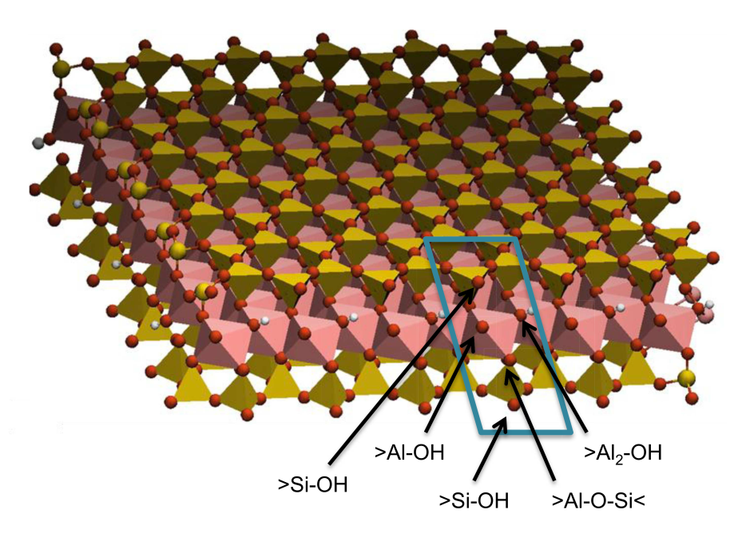
Figure A1. Position of the various functional groups at the edge surface of the TOT layer.

Figure A2. Relationship between the bond valence (b.v.) and the partial charge of O atoms in the CLAYFF model (open circles)

REFERENCES
Babcock, K.L. (1960) Some characteristics of a model Donnan system. Soil Science, 90, 245–252.
Hedström, M. and Karnland, O. (2012) Donnan equilibrium in Na-montmorillonite from a molecular dynamics perspective. Geochimica et Cosmochimica Acta, 77, 266–274.
Holmboe, M., Wold, S., and Jonsson, M. (2012) Porosity investigation of compacted bentonite using XRD profile modeling. Journal of Contaminant Hydrology, 128, 19–32.
Low, P.F. (1951) Force fields and chemical equilibrium in heterogeneous systems with special reference to soils. Soil Science, 71, 409–418.
Sposito, G. (1981) The thermodynamics of soil solution. Oxford University Press, New York.
Sposito, G. (2004) The surface chemistry of natural particles. Oxford University Press, New York.

